FEDRAL BOARD OF INTERMEDIATE AND SECONDRY EDUCATION ISLAMABAD

RESULT CANCELATION CERTIFICATE

The result of {{Candidate_name}} S / D / O {{Father_name}}

______________________ ________________________

Bearing Roll no. {{Roll_no}} and Registration No. {{Registration_no}}

___________ _______________

Who appeared in SSC-1 Annual Examination 2021 is hereby cancelled

On his / her own request. He / She is allowed to appear in the coming

SSC-1 / SSC-1&11 Annual Examination, if otherwise eligible.

Dated {{Dated}} 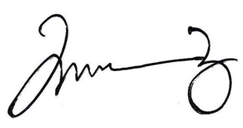 ______________

CONTROLLER OF EXAMINATION